HARDWARE LAB 1

Combinational Design

Digital Design: CPEN214

NAME: __Wade Madden___

**Part I – Half adder**

A half-adder is an arithmetic circuit that adds two bits A, and B, and generates two outputs, the SUM and CARRY.

Truth table for the half-adder:

|  |  |  |  |
| --- | --- | --- | --- |
| **A** | **B** | **SUM** | **CARRY** |
| 0 | 0 | 0 | 0 |
| 0 | 1 | 1 | 0 |
| 1 | 0 | 1 | 0 |
| 1 | 1 | 0 | 1 |

K-Map for SUM:

|  |  |
| --- | --- |
| 0 | 1 |
| 1 | 0 |

Boolean Expression for SUM: A’B + AB’

K-Map for CARRY:

|  |  |
| --- | --- |
| 0 | 0 |
| 0 | 1 |

Boolean Expression for CARRY: AB

Half Adder

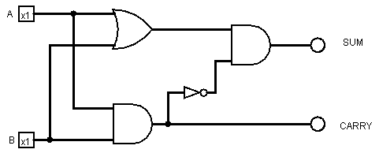

It is possible to implement the SUM function with only one gate XOR because the XOR gate returns true only when A is true and B is false or when B is true and A is false.

Full-adder design using two half-adders (Logisim).

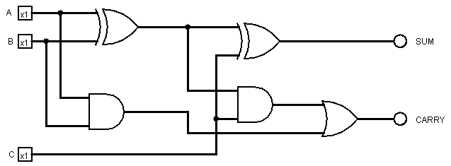

Truth table full-adder.

|  |  |  |  |  |
| --- | --- | --- | --- | --- |
| **A** | **B** | **C** | **SUM** | **CARRY** |
| 0 | 0 | 0 | 0 | 0 |
| 0 | 0 | 1 | 1 | 0 |
| 0 | 1 | 0 | 1 | 0 |
| 0 | 1 | 1 | 0 | 1 |
| 1 | 0 | 0 | 1 | 0 |
| 1 | 0 | 1 | 0 | 1 |
| 1 | 1 | 0 | 0 | 1 |
| 1 | 1 | 1 | 1 | 1 |

**Part II – Home security system**

A home security system can be illustrated by a simple logic circuit as shown below. The ALARM is on if PANIC is on, OR the owners are NOT EXITING, the system is ENABLED, AND the WINDOW, DOOR, AND GARAGE are NOT SECURE (alternatively, not secure means one of the WINDOW, DOOR, OR GARAGE is off (0)). Note that the system is SECURE if WINDOW, DOOR, AND GARAGE are all on (1).



This table should include all input combinations that will ‘set off’ the alarm (= logic high).

Truth table for the home security system: (you may need to add more rows)

|  |  |  |  |  |  |  |
| --- | --- | --- | --- | --- | --- | --- |
| **Panic** | **Enable** | **Exiting** | **Window** | **Door** | **Garage** | ALARM |
| 1 | x | x | x | x | x | 1 |
| 0 | 1 | 0 | 0 | 0 | 0 | 1 |
| 0 | 0 | 0 | 0 | 0 | 1 | 0 |
| 0 | 0 | 0 | 0 | 1 | 0 | 0 |
| 0 | 0 | 0 | 0 | 1 | 1 | 0 |
| 0 | 0 | 0 | 1 | 0 | 0 | 0 |
| 0 | 0 | 0 | 1 | 0 | 1 | 0 |
| 0 | 0 | 0 | 1 | 1 | 0 | 0 |
| 0 | 0 | 0 | 1 | 1 | 1 | 0 |
| 0 | 0 | 1 | 0 | 0 | 0 | 0 |
| 0 | 0 | 1 | 0 | 0 | 1 | 0 |
| 0 | 0 | 1 | 0 | 1 | 0 | 0 |
| 0 | 0 | 1 | 0 | 1 | 1 | 0 |
| 0 | 0 | 1 | 1 | 0 | 0 | 0 |
| 0 | 0 | 1 | 1 | 0 | 1 | 0 |
| 0 | 0 | 1 | 1 | 1 | 0 | 0 |
| 0 | 0 | 1 | 1 | 1 | 1 | 0 |
| 0 | 1 | 0 | 0 | 0 | 1 | 1 |
| 0 | 1 | 0 | 0 | 1 | 0 | 1 |
| 0 | 1 | 0 | 0 | 1 | 1 | 1 |
| 0 | 1 | 0 | 1 | 0 | 0 | 1 |
| 0 | 1 | 0 | 1 | 0 | 1 | 1 |
| 0 | 1 | 0 | 1 | 1 | 0 | 1 |
| 0 | 1 | 0 | 1 | 1 | 1 | 0 |
| 0 | 1 | 1 | 0 | 0 | 0 | 0 |
| 0 | 1 | 1 | 0 | 0 | 1 | 0 |
| 0 | 1 | 1 | 0 | 1 | 0 | 0 |
| 0 | 1 | 1 | 0 | 1 | 1 | 0 |
| 0 | 1 | 1 | 1 | 0 | 0 | 0 |
| 0 | 1 | 1 | 1 | 0 | 1 | 0 |
| 0 | 1 | 1 | 1 | 1 | 0 | 0 |
| 0 | 1 | 1 | 1 | 1 | 1 | 0 |

Difficulties:

When creating the half adder circuit on the breadboard the resistors were forgotten. So it took a bit of time to find the mistake because everything looked correct. After this mistake was fixed the circuit worked perfectly and the security system circuit was completed shortly after.

*Typed Report checklist:*

1. Completed Half-Adder table
2. K-Maps
3. Boolean expressions part I
4. Circuit Diagram part I
5. Answer to question part I
6. Full-adder design using two half-adders
7. Truth table for full adder
8. Security system results in a table form
9. Difficulties